More than 50 children and youth are waiting for safe and nurturing homes of their own.

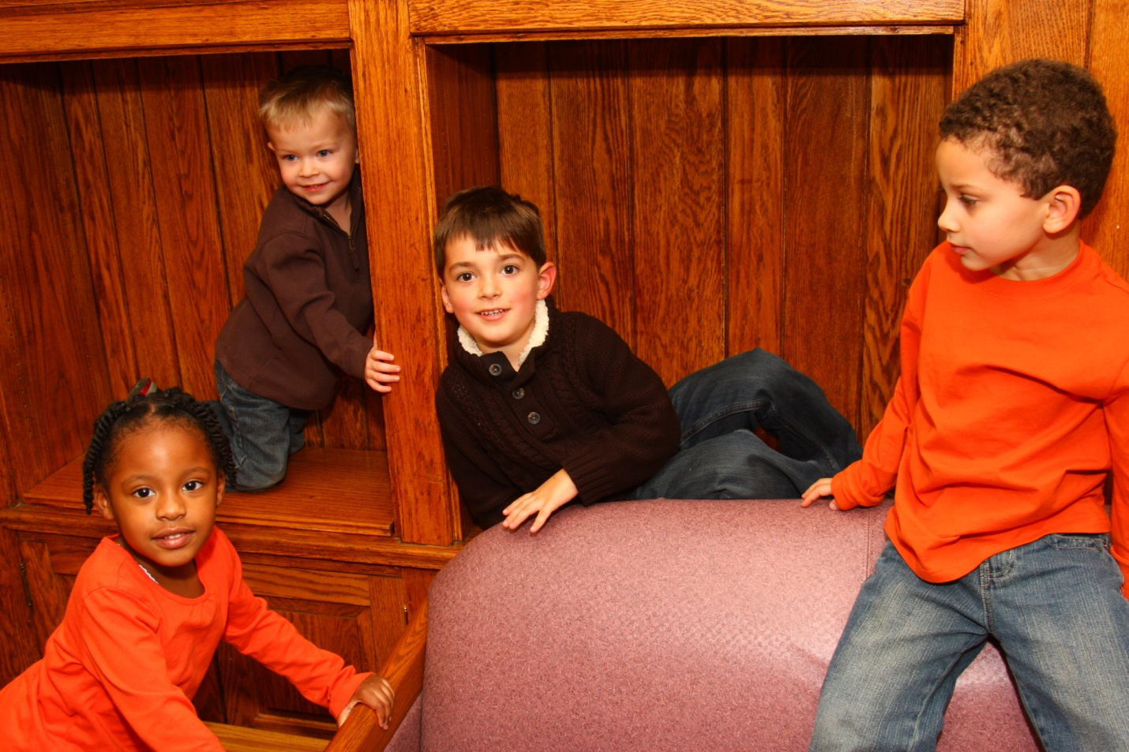

Are you ready to share your love, your hopes, and dreams?

If so, please contact:
Maryland Foster Care Recruiter at 301 365-4480 ext 114
DC Foster Care Recruiter at 202 369-9330 ext 25

