BATES AREA CIVIC ASSOCIATION
OFFICIAL BALLOT October 3, 2016

PRESIDENT (select one) * are incumbents
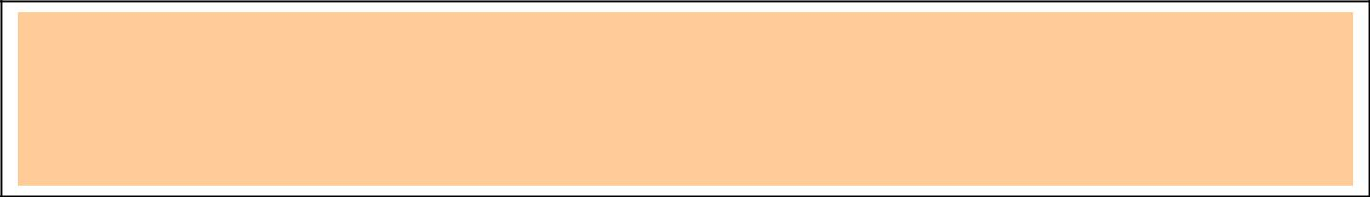

______ Kyle Thomas

______ Geovani Bonilla

______ Write-in ____________________________________________________________

VICE PRESIDENT (select one)
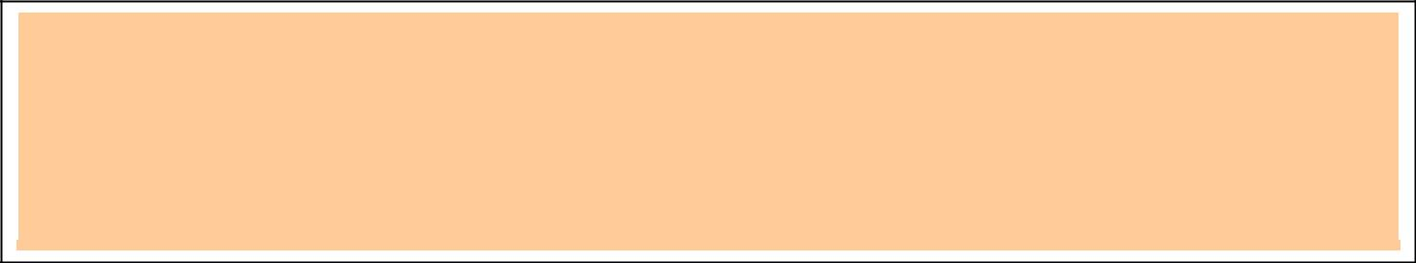

______ Geovani Bonilla*

______ Write-in _____________________________________________________________

SECRETARY (select one)
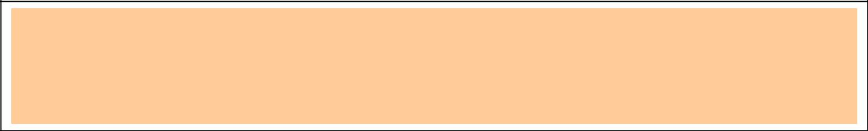

______ Kate Mevis

______ Write-in _____________________________________________________________

TREASURER (select one)
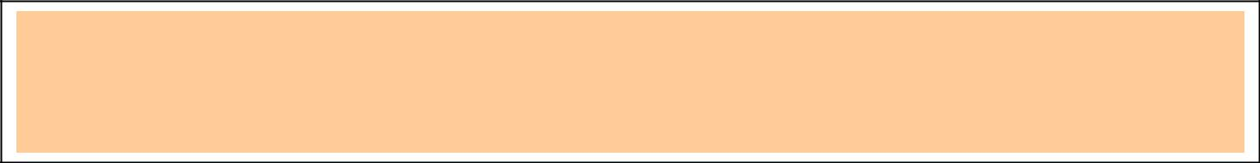

______ Katherine (Katie) McClelland

______ Write-in __________________________________________________________

AT-LARGE (select 4 or Write-In additional names to make 4 total)


______ Harold Gist *

______ Christa Fields

______ Terry Rhea

______ Write-in ________________________________________________________

