  1st Street NW
  Nominees
  front yards
  1540
  1536
  1532
  1518
  1502
  1500
  Your Choice Front Yard:
  3rd Street NW
  Nominees
  Front yards
  1406
  1506
  1508
  1556
  1606
  tree boxes
  1542
  1544
  Your Choice Front Yard:
  Your Choice Tree Box:
  4th St NW
  Nominees
  FRONT YARDS
  1622
  1644
  Your Choice Front Yard:
  Bates St NW
  Nominees
  Front Yard
  24 Bates
  54 Bates
  72 Bates
  124 Bates
  127 Bates
  207 Bates
  Your Choice Front Yard:
  Your Choice Tree Box:
  P St NW
  Nominees
  Front Yards  49 P  51 P  61 P  81 P  107 P  312 P  314 P | P St Tree Boxes  61 P  65 P
  Your Choice Front Yard:
  Your Choice Tree Box:
  Q St NW
  Nominees
  Front Yards
  41 Q
  58 Q
  216 Q
  Tree Boxes
  41 Q
  Your Choice Front Yard:
  Your Choice Tree Box:
  R St NW
  Nominees
  Front Yards
  400
  404
  Your Choice Front Yard:
  Instructions
  Your Choice Front Yard:
  Your Choice Tree Box:

Bates Area Civic Association
2017 Flower Power Voting Ballot
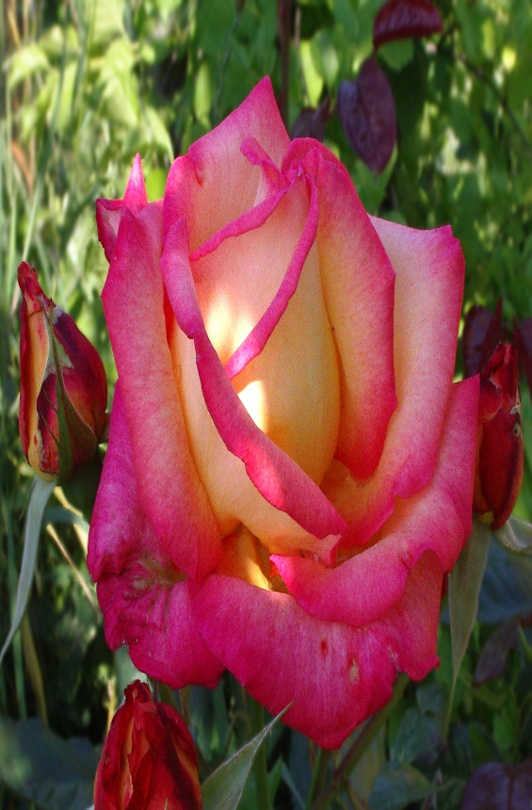
Select one front yard and tree box per street.

